Name: Somnath R. Shintre Roll No:

Class: TE CSE Batch:

**Title: -** Write a GUI based program to create a student registration and Login. Store Registration data in Database and take Login information from Database.

**Program: - Registration GUI**

import javax.swing.*;

import java.awt.*;

import java.awt.event.*;

import java.sql.*;

import javax.swing.border.*;

public class JDBC_GUI_Registration extends JFrame

{

private JFrame jf;

private JPanel contentPane;

private JTextField firstname;

private JTextField lastname;

private JTextField email;

private JTextField username;

private JTextField mob;

private JPasswordField passwordField;

private JButton btnNewButton;

JDBC_GUI_Registration(){

setDefaultCloseOperation(JFrame.EXIT_ON_CLOSE);

setBounds(450, 190, 1014, 597);

setResizable(false);

setTitle("Registration Form");

contentPane = new JPanel();

contentPane.setBorder(new EmptyBorder(5, 5, 5, 5));

setContentPane(contentPane);

contentPane.setLayout(null);

JLabel lblNewUserRegister = new JLabel("New User Register");

lblNewUserRegister.setFont(new Font("Times New Roman", Font.PLAIN, 42));

lblNewUserRegister.setBounds(362, 52, 325, 50);

contentPane.add(lblNewUserRegister);

JLabel lblName = new JLabel("First name");

lblName.setFont(new Font("Tahoma", Font.PLAIN, 20));

lblName.setBounds(58, 152, 99, 43);

contentPane.add(lblName);

JLabel lblNewLabel = new JLabel("Last name");

lblNewLabel.setFont(new Font("Tahoma", Font.PLAIN, 20));

lblNewLabel.setBounds(58, 243, 110, 29);

contentPane.add(lblNewLabel);

JLabel lblEmailAddress = new JLabel("Email\r\n address");

lblEmailAddress.setFont(new Font("Tahoma", Font.PLAIN, 20));

lblEmailAddress.setBounds(58, 324, 124, 36);

contentPane.add(lblEmailAddress);

firstname = new JTextField();

firstname.setFont(new Font("Tahoma", Font.PLAIN, 32));

firstname.setBounds(214, 151, 228, 50);

contentPane.add(firstname);

firstname.setColumns(10);

lastname = new JTextField();

lastname.setFont(new Font("Tahoma", Font.PLAIN, 32));

lastname.setBounds(214, 235, 228, 50);

contentPane.add(lastname);

lastname.setColumns(10);

email = new JTextField();

email.setFont(new Font("Tahoma", Font.PLAIN, 32));

email.setBounds(214, 320, 228, 50);

contentPane.add(email);

email.setColumns(10);

username = new JTextField();

username.setFont(new Font("Tahoma", Font.PLAIN, 32));

username.setBounds(707, 151, 228, 50);

contentPane.add(username);

username.setColumns(10);

JLabel lblUsername = new JLabel("Username");

lblUsername.setFont(new Font("Tahoma", Font.PLAIN, 20));

lblUsername.setBounds(542, 159, 99, 29);

contentPane.add(lblUsername);

JLabel lblPassword = new JLabel("Password");

lblPassword.setFont(new Font("Tahoma", Font.PLAIN, 20));

lblPassword.setBounds(542, 245, 99, 24);

contentPane.add(lblPassword);

JLabel lblMobileNumber = new JLabel("Mobile number");

lblMobileNumber.setFont(new Font("Tahoma", Font.PLAIN, 20));

lblMobileNumber.setBounds(542, 329, 139, 26);

contentPane.add(lblMobileNumber);

mob = new JTextField();

mob.setFont(new Font("Tahoma", Font.PLAIN, 32));

mob.setBounds(707, 320, 228, 50);

contentPane.add(mob);

mob.setColumns(10);

passwordField = new JPasswordField();

passwordField.setFont(new Font("Tahoma", Font.PLAIN, 32));

passwordField.setBounds(707, 235, 228, 50);

contentPane.add(passwordField);

btnNewButton = new JButton("Register");

btnNewButton.addActionListener(new ActionListener() {

public void actionPerformed(ActionEvent e) {

String firstName = firstname.getText();

String lastName = lastname.getText();

String emailId = email.getText();

String userName = username.getText();

String mobileNumber = mob.getText();

int len = mobileNumber.length();

String password = passwordField.getText();

String msg = "" + firstName;

msg += " \n";

if (len != 10) {

JOptionPane.showMessageDialog(lblNewUserRegister, "Enter a valid mobile number");

}

Connection con = null;

PreparedStatement ps = null;

try {

Class.forName("oracle.jdbc.OracleDriver");

con = DriverManager.getConnection("jdbc:oracle:thin:@localhost:1521:orcl", "sgmcoe", "som123");

ps = con.prepareStatement("insert into JDBC_STUDENT_REGISTRATION values(?,?,?,?,?,?)");

ps.setString(1,firstName);

ps.setString(2,lastName);

ps.setString(3,userName);

ps.setString(4,password);

ps.setString(5,emailId);

ps.setString(6,mobileNumber);

int x = ps.executeUpdate();

if (x == 0) {

JOptionPane.showMessageDialog(lblNewUserRegister, "This is alredy exist");

} else if(x>0) {

JOptionPane.showMessageDialog(lblNewUserRegister, "Welcome, " + msg + "Your account is sucessfully created");

} else {

JOptionPane.showMessageDialog(lblNewUserRegister, "Somethings Wrong");

}

con.close();

} catch (Exception exception) {

exception.printStackTrace();

}

}

});

btnNewButton.setFont(new Font("Tahoma", Font.PLAIN, 22));

btnNewButton.setBounds(399, 447, 259, 74);

contentPane.add(btnNewButton);

}

public static void main(String args[]){

JDBC_GUI_Registration frame = new JDBC_GUI_Registration();

frame.setVisible(true);

}

}

**Output: -**

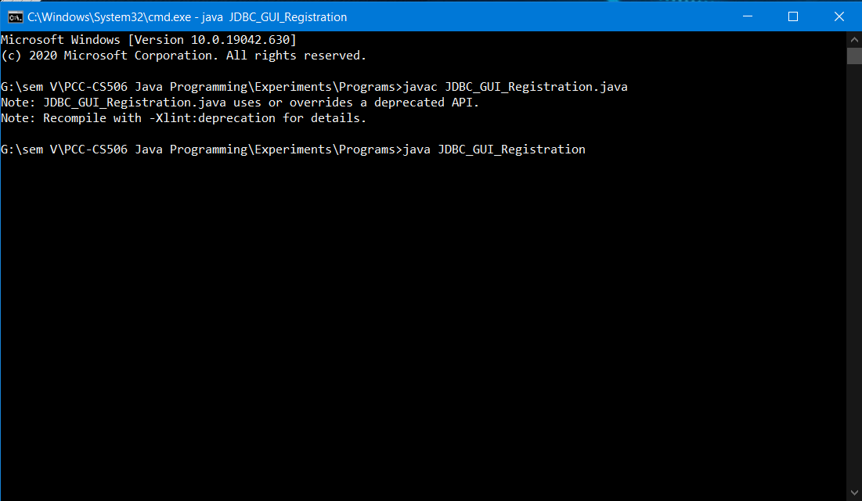

**New User Register Page:**

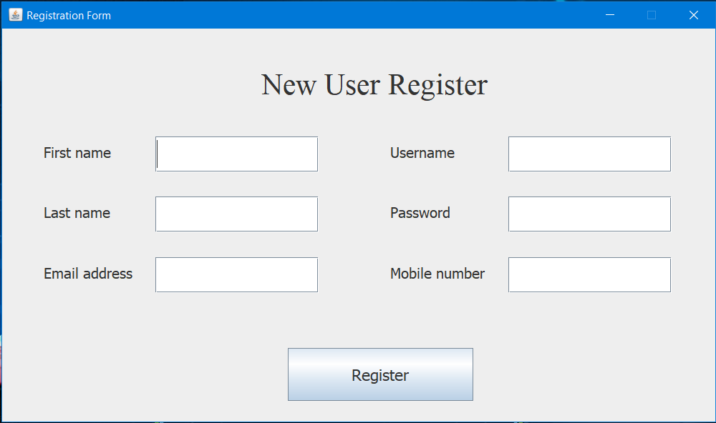

### **Enter User Details in Register Page:**

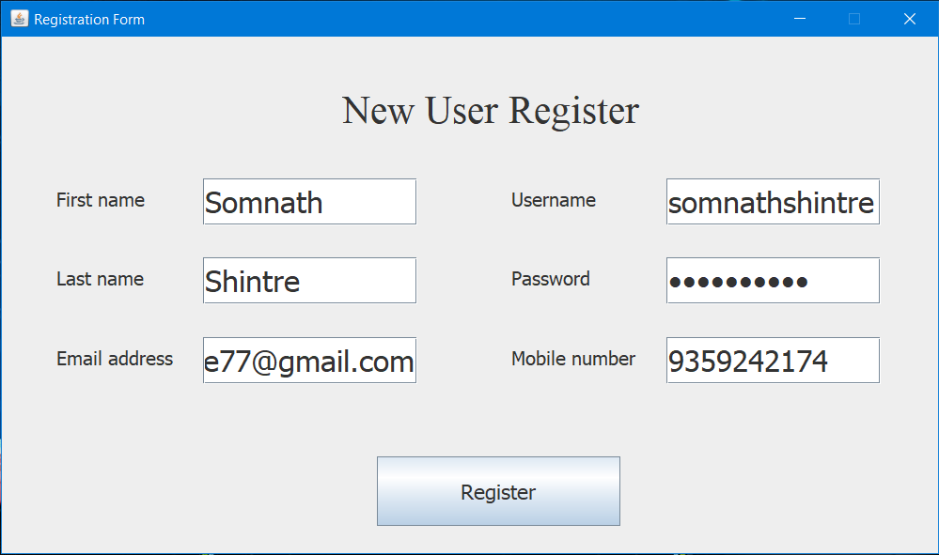

### **After the User Registration:**

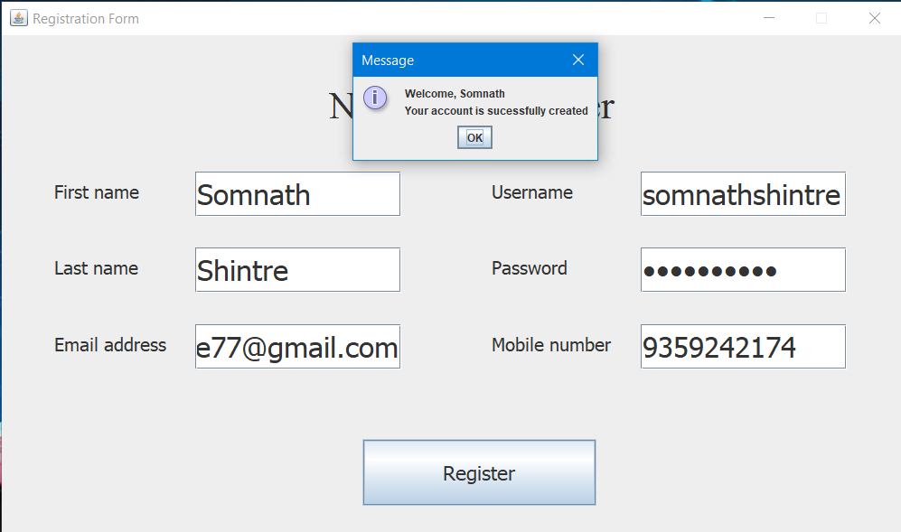

**Program: - Login GUI**

import javax.swing.*;

import java.awt.*;

import java.awt.event.*;

import java.sql.*;

import javax.swing.border.*;

public class JDBC_GUI_Login extends JFrame

{

private JTextField textField;

private JPasswordField passwordField;

private JButton btnNewButton;

private JLabel label;

private JPanel contentPane;

JDBC_GUI_Login()

{

setDefaultCloseOperation(JFrame.EXIT_ON_CLOSE);

setBounds(450, 190, 1014, 597);

setResizable(false);

setTitle("Login Form");

contentPane = new JPanel();

setContentPane(contentPane);

contentPane.setLayout(null);

JLabel lblNewLabel = new JLabel("Login");

lblNewLabel.setForeground(Color.BLACK);

lblNewLabel.setFont(new Font("Times New Roman", Font.PLAIN, 46));

lblNewLabel.setBounds(423, 13, 273, 93);

contentPane.add(lblNewLabel);

textField = new JTextField();

textField.setFont(new Font("Tahoma", Font.PLAIN, 32));

textField.setBounds(481, 170, 281, 68);

contentPane.add(textField);

textField.setColumns(10);

passwordField = new JPasswordField();

passwordField.setFont(new Font("Tahoma", Font.PLAIN, 32));

passwordField.setBounds(481, 286, 281, 68);

contentPane.add(passwordField);

JLabel lblUsername = new JLabel("Username");

lblUsername.setBackground(Color.BLACK);

lblUsername.setForeground(Color.BLACK);

lblUsername.setFont(new Font("Tahoma", Font.PLAIN, 31));

lblUsername.setBounds(250, 166, 193, 52);

contentPane.add(lblUsername);

JLabel lblPassword = new JLabel("Password");

lblPassword.setForeground(Color.BLACK);

lblPassword.setBackground(Color.CYAN);

lblPassword.setFont(new Font("Tahoma", Font.PLAIN, 31));

lblPassword.setBounds(250, 286, 193, 52);

contentPane.add(lblPassword);

btnNewButton = new JButton("Login");

btnNewButton.setFont(new Font("Tahoma", Font.PLAIN, 26));

btnNewButton.setBounds(545, 392, 162, 73);

btnNewButton.addActionListener(new ActionListener() {

public void actionPerformed(ActionEvent e) {

String userName = textField.getText();

String password = passwordField.getText();

Connection con = null;

Statement st = null;

try {

Class.forName("oracle.jdbc.OracleDriver");

con = DriverManager.getConnection("jdbc:oracle:thin:@localhost:1521:orcl", "sgmcoe", "som123");

st=con.createStatement();

ResultSet rs=st.executeQuery("Select * from JDBC_STUDENT_REGISTRATION where user_name='"+userName+"' and password ='"+password+"'");

if (rs.next()) {

JOptionPane.showMessageDialog(lblNewLabel, "You have successfully logged in");

} else {

JOptionPane.showMessageDialog(lblNewLabel, "Wrong Username & Password");

}

con.close();

} catch (Exception exception) {

exception.printStackTrace();

}

}

});

contentPane.add(btnNewButton);

label = new JLabel("");

label.setBounds(0, 0, 1008, 562);

contentPane.add(label);

}

public static void main(String args[]){

JDBC_GUI_Login fram = new JDBC_GUI_Login();

fram.setVisible(true);

}

}

**Output: -**



**User Login**

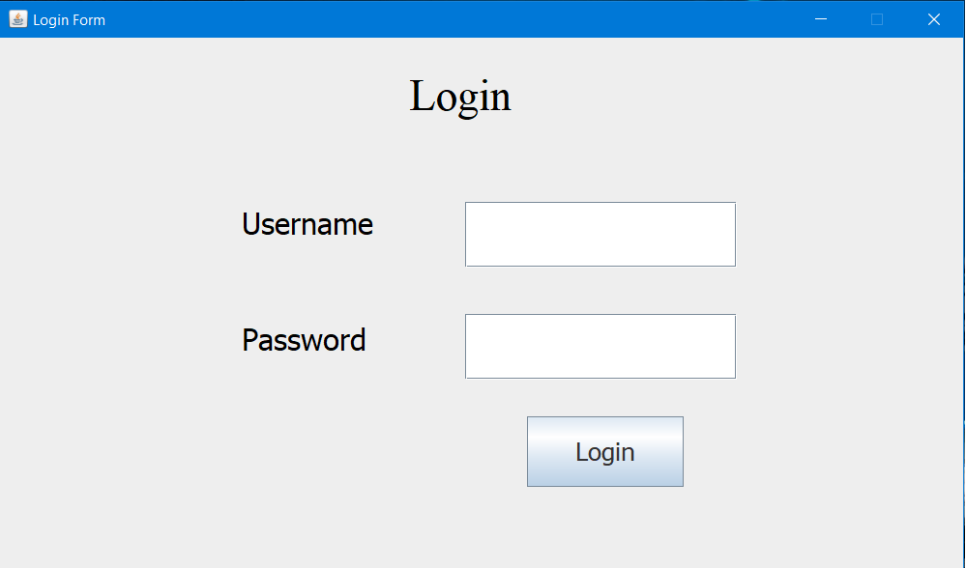

### **Enter User Details in Login Page:**



### **After the User Login:**

